DRAFT
Ocean Decade – Arctic Action Plan

in support of the United Nations Decade for Ocean Science for Sustainable Development

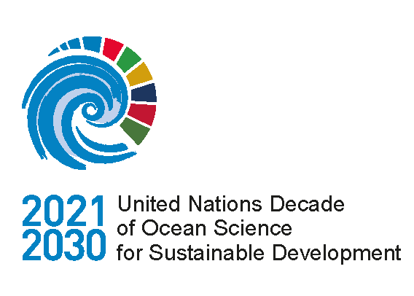

Ocean Decade – Arctic Action Plan

Contents

Prologue 3
Brief summary of the Arctic process 1
The ‘Ocean Decade – Arctic Action Plan’ 1
The target group 1
The scope of the Plan 1
The Action Plan 2
The need for an Ocean Decade - Arctic Action Plan 1
Identified key cross-cutting barriers to overcome 2
Barrier 1: A disconnected Arctic 2
Barrier 2: Insufficient means to ensure safety and health in the Arctic 3
Barrier 3: Inadequate knowledge of the value and distribution of resources 3
Barrier 4: Inadequate management of Arctic marine ecosystems 3
Barrier 5: Inadequate support to the Arctic region 4
The Arctic Action Plan 5
Research challenges – to achieve transformative ocean science solutions 6
Organisational challenges – for achieving high impact science in the region 10
Uptake challenges - to enhance societal benefit of ocean science in the Arctic 13
Annex 18
A) The Arctic Action Plan development process 18
B) Existing and planned activities and initiatives that address the Action Plan 20

Prologue
The United Nations Decade of Ocean Science for Sustainable Development (2021-2030) (‘Ocean Decade’) represents a unique opportunity to rally global scientific and societal capacities towards addressing pressing societal challenges for sustainable development. While the marine environment on planet earth may be viewed as one extended ocean, sustainable development consists of highly complex regional challenges spanning both environmental, economic and social dimensions. Actions to address these challenges therefore require coordinated implementation at global, regional and local levels, including in the Arctic.
Based on the recommendations in the global Ocean Decade implementation plan and with support from IOC of UNESCO, a series of regional workshops were encouraged in order to inform the development of the Implementation Plan for the Ocean Decade and develop regional action plans. The initiative for the Arctic started with a one-day Policy - Business - Science Dialogue meeting in Tromsø, Norway hosted by the Research Council of Norway, as part of the Arctic Frontiers conference in January 2020. This was to be followed by a three-day workshop in April in Copenhagen, Denmark hosted by the Danish Centre for Marine Research where the Action Plan could be developed. Due to the COVID-19 pandemic, this was transformed in a series of online workshops held in October and November of 2020 for which working groups organized around the seven Decade Societal Outcomes were established. About >300 participants from industry, science, governments, NGOs and the broader public (See Annex C for breakdown of participant affiliations) discussed the barriers and scientific challenges for reaching sustainable development and potential science-based solutions that could help achieve them. This culminated in an online consultation in the beginning of 2021, where the plan at hand was reviewed and finalised.
With this first Action Plan we hope that the Ocean Decade community will find inspiration and guidance to deliver transformative ocean science solutions for sustainable development in the Arctic region. As a bottom-up co-creation process with no formal restrictions for participants, the plan represents a global community driven effort with no formal ownership or legal mandate. This should be seen as a strength given the Ocean Decade’s ambitions of creating the highest level of momentum from all corners of society. Going forward this inclusive approach has to be further strengthened, in particular in relation to engaging the different Arctic communities, as the plan is revised and updated during the Decade.
The Arctic region is now positioned to join the Ocean Decade

Brief summary of the Arctic process

The ‘Ocean Decade – Arctic Action Plan’

This plan aims to provide Arctic stakeholders with a shared agenda, to kick-start the implementation of actions in support of the United Nations Decade for Ocean Science for Sustainable Development (2021-2030) (‘Ocean Decade’) in their region. The Ocean Decade is a global endeavour to create a significant collaborative momentum for ocean-related sustainable development and science. This plan is the first regional action plan under the umbrella of the Ocean Decade. It presents a first wave of challenges to address in the region. These challenges and the recommendations for their implementation are expected to be updated throughout the Decade as more stakeholders engage, our knowledge improves and the needs in the region change.

The target group
The target group of the plan is broad including the general public and Arctic communities but is of particular relevance for stakeholders working on strategies to support ocean science and accelerate sustainable development in the region via research, management, business development, policy or financial supporting mechanisms. These stakeholder groups are the key actors in the global Ocean Decade, and are thus expected to take the initiative forward, acting to both fulfil the stated challenges and revising the plan during the decade with new actions to address missing or arising issues. The plan is not owned by anyone nor legally binding for any institution or government irrespective of their contribution to the development.

The scope of the Plan
While the Ocean Decade is clearly tied to Sustainable Development Goal (SDG) 14 ‘Life below water’, this regional action, as with the global implementation plan, aims to support progress towards all of the Sustainable Development goals through the application of ocean science. This includes in particular SDG 12 ‘Responsible consumption and production’ and 13 ‘Climate action’.

Geographically the regional plan spans the entire Arctic and its marine and coastal areas including the Bering Sea in line with the area covered by ‘The Agreement on enhancing international Arctic scientific cooperation.

The purpose of the action Plan is to identify mechanisms to achieve the Ocean Decade’s goals, which are defined as the following Societal Outcomes:

- A clean ocean where sources of pollution are identified, reduced or removed
- A healthy and resilient ocean where marine ecosystems are understood and managed
- A productive ocean supporting sustainable food supply and a sustainable ocean economy
- A predicted ocean where society understands and can respond to changing ocean conditions
- A safe ocean where life and livelihoods are protected from ocean-related hazards
- An accessible ocean with open and equitable access to data, information and technology and innovation
- An inspiring and engaging ocean where society understands and values the ocean in relation to human wellbeing and sustainable development

To deliver this, the Arctic Process has focused on answering of two key questions:

- What are the barriers that hinder progress towards achieving the Societal Outcomes of the Ocean Decade in the region?

- What transformative ocean science solutions will help overcome these barriers and how could they be implemented throughout the Ocean Decade?

The Action Plan

The Arctic process produced a number key insights, particularly related to the presence of cross-cutting barriers for progress. These spanned broadly from purely scientific gaps in understanding and data availability, to organizational issues concerning efficient international coordination and the lack of tools and services to make new knowledge products accessible for industry, governance and the public. To mirror this, the plan has been structured around three types of challenges and their suggested solutions.

Research challenges – core scientific areas which should be advanced to enable the production of transformative ocean science solutions

Organizational challenges – issues related to providing and supporting efficient coordination, funding, infrastructure, data management and public support to activities in the region

Uptake challenges – options for enhancing and accelerating the societal uptake and benefits of ocean science solutions in the region

Research challenges – to achieve transformative ocean science solutions

The Ocean Decade’s call for transformative ocean science can be synthesized into four overarching themes for the Arctic region. Each theme covers a list of specific challenges, ideal for a dedicated research agenda or specific development projects (Annex B).

Transformative Solution 1: Provide the Arctic region with a detailed open-access inventory of spatial and temporal information on bathymetry, presence of geo and biodiversity, disaster and pollution risks, provisioning of ecosystem services and their value to support evidence-based decision making.

Transformative Solution 2: Understand the core Arctic climate and ecosystem dynamics; the impacts of anthropogenic pressures on the environment and ecosystem; and the mechanisms which threaten human health and safety in the region.

Transformative Solution 3: Observe the state of Arctic environments and development trends in near-real time supported by information services tailored to the needs of science, management and industry. This includes sustained observation programmes to establish baselines and trends in: ice distribution; weather and sea state; ecosystem structure and dynamics; distribution of natural resources; carbon cycling; anthropogenic pressures; ocean circulation; and spatial and temporal distribution of contaminants.

Transformative Solution 4: Predict and forecast Arctic climate and ecosystem dynamics on scales from hours to millennia, to enable climate adaptation and ecosystem-based management of human activities.

Organisational challenges – for achieving high impact science in the region
There is a strong community awareness of pivotal importance of international collaboration and organizational support to deliver high impact solutions in the region. This relates in particular to efficient international coordination, adequate funding, infrastructure and equipment availability, data management and political support. To emphasize this and catalyse progress, the Plan presents a dedicated agenda to advance these priorities, with details provided on page 10.

- Connecting the Arctic
- Establishing large-scale sustained internationally co-funded programmes
- Collaborating and coordinating ongoing and future Arctic research, management and observation programmes
- Collaborating on creating and maintaining joint open data sharing platforms.
- Co-designing and producing actions linking across local, national and regional communities
- Collaborating with key stakeholders throughout the Arctic on increasing global awareness of Arctic issues and ocean literacy in the region
- Developing technology to improve temporal and geographical coverage of multidisciplinary observation programs in the region

Uptake challenges - to enhance societal benefit of ocean science in the Arctic

While ocean science is at the foundation of the Action Plan, the benefits arising from it, require dedicated actions to realise its full potential across management, industry and society. To accelerate progress, the plan presents an agenda which highlights particular challenges which should be addressed. These relate to the end of the ‘knowledge value chain’ where scientific progress is translated into tangible services and products and ultimately bringing society closer to the desired societal outcomes of the decade.

- Developing the information services necessary for safe navigation.
- Developing Search And Rescue (SAR) and Oil Spill Response (OSR) capacity.
- Coordinated management and response to risks and disasters.
- Managing the marine and coastal environments through an integrated framework.
- Managing vulnerable habitats or threatened species through designation of marine protected areas.
- Managing the marine and coastal areas with adequate enforcement measures.
- Collaborating with key industry stakeholders and governments to create an Arctic-Specific Corporate Social Responsibility (CSR) program.

The need for an Ocean Decade - Arctic Action Plan
The Arctic region is closely linked with its marine environment and is currently experiencing dramatic changes as a consequence of climate change. This change is impacting local communities and ecosystems but also has regional and global implications for industries, governance and the earth system itself.
Some of these changes present challenges while others provide new opportunities for sustainable development of the region. The underlying requirement is that relevant stakeholders collaborate to harvest the full potential of science and technology to ensure the optimal social, economic and environmental outcome.
In recognition of the oceans’ potential for supporting sustainable development, the United Nation’s has launched the Decade for Ocean Science of Sustainable Development (the Ocean Decade, 2021-2030) which will provide a unifying global framework for supporting and communicating the need for transformative ocean related actions. Over the coming ten years the decade is anticipated to mobilise new opportunities for collaborations and partnerships among coastal, marine and maritime stakeholders based on a shared understanding of the need for joint global efforts to achieve the Sustainable Development Goals for all regions of the world. In terms of the Ocean Decade, this is translated into the achievement of the decade’s societal outcomes as defined in the global implementation plan (figure 1).
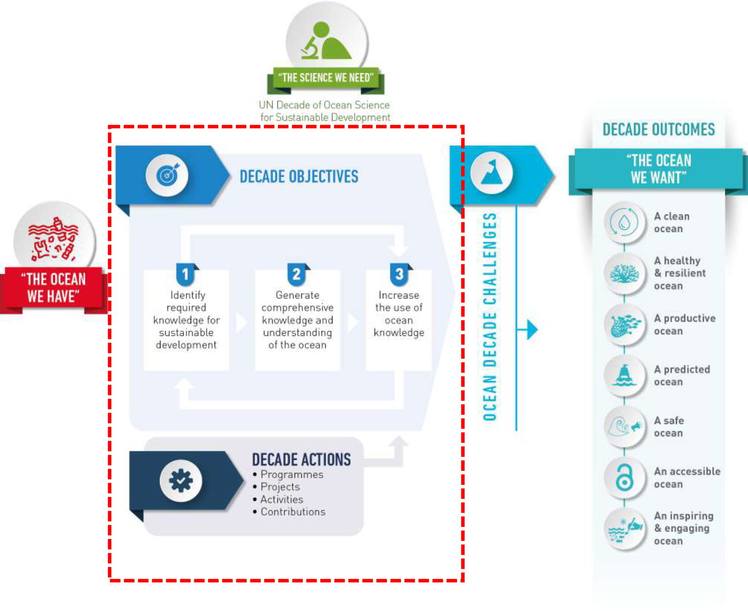
Figure 1: Objectives and Actions of the Ocean Decade
From an Arctic perspective the Ocean Decade therefore presents an opportunity to rally global scientific and societal capacities around the regions pressing challenges and opportunities.
To seize this opportunity, IOC UNESCO has encouraged the development of international efforts to lead a bottom-up process at a regional level. The aim is to develop regional Action Plans which clearly describe how the envisioned Societal Outcomes of the Ocean Decade may be achieved through science-based actions.
The key ambition of this ‘Ocean Decade - Arctic Action Plan’ is therefore to:
- Provide all stakeholders with a shared perspective on how to interpret and translate the objectives of the Ocean Decade in an Arctic context
- Provide a consolidated list of high-level challenges for the Arctic region which should be addressed as a part of the Ocean Decade as stakeholders align their efforts and draft partnerships in support of the decade
Fortuitously, cross-border international collaboration on policy, science and innovation already has high-level support in the countries located in the Arctic. With this first regional Ocean Decade plan, the Arctic region should therefore be well positioned to kick-start the Decade.

Identified key cross-cutting barriers to overcome
During the Arctic consultation process multiple barriers for progress towards the Decade’s goals were identified. Many of them are not unique for the region and almost all were found to cut across working groups dedicated to each societal outcome.

Barrier 1: A disconnected Arctic
In a disconnected Arctic, communities, industries, science and governments are hindered from benefitting from collaborative efforts. This creates a risk of: i) duplication or even opposing efforts; ii) misunderstanding of local needs and culture; iii) sustained regional inequality with respect to societal development; and iv) missing the opportunity to benefit from experience and achievements from other regions (both within the Arctic and beyond). A prerequisite for progress is an increased focus on improving communication and connectivity within and to the Arctic across the domains of physical, digital and human infrastructure.

Barrier 2: Insufficient means to ensure safety and health in the Arctic
The Arctic is a remote region where conditions are changing and where livelihoods and jobs are often confronted with significant risks for people and infrastructure. A key challenge is to provide the region with the means to understand, map, manage and respond to the inherent risks related to the Arctic marine and coastal environment and its changing nature. Current risks include threats from terrestrial and sub-marine hazards, poor predictability of weather, sea and ice conditions, delayed response to environmental and human emergencies, exposure of local population and ecosystems to local and long-range transported pollution, and illegal exploitation of natural resources. Understanding and addressing these risks should thus secure a safe future for Arctic residents and the nature they depend on.

Barrier 3: Inadequate knowledge of the value and distribution of resources
The Arctic region contains considerable cultural heritage and natural resources, of which some remain poorly understood, undiscovered, under-appreciated or even unknown to the global population. Cross-border governance is a challenge where little is known about the present and future location of resources and their value both economically and culturally. Providing the Arctic region with a common detailed inventory of present resources and scenarios for future access and value, is an important step for development in the region. The availability and communication of this knowledge to all parties is an important step for local decision-making as well as increasing the global awareness of region and its importance culturally, economically and climatically.

Barrier 4: Inadequate management of Arctic marine ecosystems
Much of the Arctic’s natural capital and its related ecosystem services are linked to the marine environment and are the foundation upon which much of the development potential and cultural heritage rests. It is therefore important to understand and manage the impact of local, regional and global activities on Arctic marine ecosystems. Providing the region with the means for adaptive ecosystem-based management relies on understanding all individual physical, chemical and biological components and the interactions among them. This can then be combined into both national and international strategies where targets are set, systems are monitored, and predicted, developments are assessed, new knowledge is integrated, and achievements are evaluated. With these advances, the potential emerges to develop long-term environmentally, economically and socially sustainable blue and green economies in the Arctic.

Barrier 5: Inadequate support to the Arctic region
There is a shared global interest in understanding the status and trends in the Arctic environment and supporting its present and future management. In comparison to other areas that are rich in natural resources, there are few people inhabit the Arctic and most of the natural resources are exported from the region. Yet, the level and the type of use are anticipated to change as the sea ice retreats, opening new opportunities for shipping, fisheries, mining, petroleum activities and other industries including tourism. The iconic Arctic biodiversity is also a significant part of our global biodiversity, and physical conditions in the Arctic waters are an important driver of global climate. Thus, not only local Arctic communities but also non-Arctic nations have a direct interest in ensuring the sustainable development of the region. Providing the region with the financial, human and institutional capacity and motivation for a sustained programme of support for the necessary international activities is a key challenge. It is also a shared global responsibility to address, and it is aligned with the regional progress towards fulfilling sustainable development goals.

The Arctic Action Plan
The challenges facing the Arctic region on its path towards sustainable development of its marine and coastal areas, societies and industries are diverse. Some aspects span issues which demand scientific progress, while others relate to sharing and alignment of work effort and data which has an important institutional aspect to it. Others cover complex issues related to collaboration on international governance which is a political activity. Providing tangible proposals for actions is, therefore, a difficult task. In an attempt to overcome this, the Plan presents three overarching areas each with a dedicated agenda of specific challenges, supplemented with recommendations regarding implementation in the annex. The three areas are:
Research challenges – the core scientific areas which should be advanced to enable the production of transformative ocean science solutions

Organizational challenges – issues related to providing and supporting efficient coordination, funding, infrastructure, data management and public support to activities in the region.

Uptake challenges – the options for enhancing and accelerating the societal uptake and benefits of ocean science solutions in the region
Among the presented challenges are also some which are highly cross-cutting. These are in particular:
- The need for involvement of Indigenous people and local communities in the region, and
- Collection, management and sharing of data
Both issues are already highlighted in multiple international policies on science and sustainable development, yet clearly remain a high-level topic to explicitly address throughout the Ocean Decade, as emphasised by all working groups and consultations carried out in preparation of the Action Plan. In particular, there is a need to strengthen pathways for informing policy decisions with local and indigenous knowledge, build capacity within organizations and with individuals to understand what other forms of knowledge are available, and what best practice entails in co-designed actions. This would support the Ottawa Traditional Knowledge Principles but also the Paris Agreement which identifies a need to strengthen knowledge, technologies, practices and efforts of local communities and indigenous peoples in addressing and responding to climate change, as well as incorporating local knowledge systems into socioeconomic and environmental policies and actions.
While both cross-cutting topics are presented as explicit challenges in the plan, they should also be considered embedded in all other challenges. In relation to the data, this means, for example, that all stakeholders must acknowledge the need to address the entire data value chain from data production/collection systems to data management systems to data use in products/information in all challenges.

Research challenges – to achieve transformative ocean science solutions

The Ocean Decade’s call for transformative ocean science, can for the Arctic region be synthesized into four overarching solutions each comprised of a subset of research challenges:

Transformative Solution 1: Provide the Arctic region with a detailed open access inventory.

The inventory should include spatial and temporal information on bathymetry, oceanographic conditions, presence of geo and biodiversity, disaster and pollution risks, and provisioning of ecosystem services and their value. The aim is to enable transparent evidence-based discussions and decision-making concerning what areas or resources should be managed in particular ways

Research challenges include:

- Mapping natural capital geo- and biodiversity, and establishing where the Arctic nature contributes to the welfare of people within and outside the Arctic
It is important to identify where and when ecosystem services are provided throughout the Arctic and who the beneficiaries are both regionally and globally (through for example climate services). This includes seabed and habitat mapping activities, assessment of the distributions and migration of living marine organisms throughout the Arctic and neighbouring seas to understand connectivity and the demand for shared management of key resources such as fish and marine mammals. New observational technologies can be adapted and exploited to open the possibility for new and more efficient data collection and cover knowledge gaps. This will support integrated ecosystem assessments and leverage the ongoing efforts by regional organisations.

- Map the present and future value of Arctic ecosystem services and how they are valued within and outside the Arctic
This challenge relates to advancing frameworks and systematic mapping and consensus-based analyses of the ‘value’ and the way people ‘value’ the Arctic nature’s contributions to them. It will need to bridge value systems by advancing analysis of both use and non-use values. This should include documentation and mapping of indigenous and local knowledge about ecosystem services, their cultural values and other practices that are not well documented or considered in the historical context. Efforts should go into connecting Indigenous and scientific knowledge in equitable ways for understanding and communicating values to relevant policy levels. As a part of actions mappings should include both present resource uses and the prospects for increased Arctic development and resource use. This should also support:
- The identification of areas where activities by one sector may reduce or increase value for other sectors incl. options for reducing cross-sector trade-offs or increase synergies (i.e. steps towards spatial planning).
- The identification of forgone value from poor management—i.e., what have been and are continuously lost by failing to practice integrated ecosystem management, investing in supporting observation programmes.
- The identification of the potential for growth in sustainable industries and activities in addition to extractive industries and their implications for Arctic communities.
- The understanding of how international agreements or conflicts affect value and management and how these will be impacted by transboundary movements as species’ ranges shift and other ecosystem services and when components are altered.

- Identify risks to human health in the Arctic and in order to enable cross-sectoral risk management
This challenge relates to risks understood in its broadest sense from disaster risks related geo-hazards such as tsunamis, navigation, or risk caused by pollution. They should be assessed both individually and cumulatively, with emphasis on discovering and characterizing risks that have previously been ignored or underestimated and those specific to the characteristics of Arctic ecosystems and communities. The scope of this challenge should include:
    - where and when climate change should be considered, as a threat to infrastructure, facilities, disaster prevention or response operations.
    - connections across regions and ecosystems that potentially expose vulnerable ecosystems and ocean health
    - how environmental and social developments affect risk and risk management including the role of area-based measures incl. protected areas and shipping
    - how to best ensure recognition of risks facing Indigenous communities and identify best practice risk management also in relation to food safety/security

Transformative Solution 2: Understand the core Arctic climate and ecosystem dynamics.

A leap in our understanding is needed regarding understanding the impacts of anthropogenic pressures on the environment and the mechanisms which threaten human health and safety in the region, allowing regional and global stakeholders to understand why and how the environment, human opportunities and threats are changing.

Research challenges include:

- Understanding the Arctic ocean-climate nexus and ecosystem dynamics
Sustainable development in the Arctic requires an enhanced understanding of the physical, chemical, biological, and geological earth system components and, the links and interactions between them. With this in hand, past, current and future climate change and its impact on society can be resolved. This challenge should address:

    - The knowledge gaps for understanding climatic, biogeochemical and ecological tipping points, which may lead to both regional and global change.
    - The diversity, status and resilience of Arctic ecosystems to discover new processes or better resolve their quantitative importance in different parts of the Arctic.
    - The development of new approaches and technologies for observing and resolving physical, chemical, biological and geological aspects of the Arctic marine environment.
    - The identification of key variables for observation programs which can best support the development and operation of predictive models.

- Understand how anthropogenic pressures impact environmental health and resilience
This challenge involves the identification and mapping of known and emerging anthropogenic pressures and the quantification of their impact on key ecosystem components and functions. It should support research towards:
- Understanding toxicity of contaminants and cumulative impacts of pressures.
- Identifying ecosystem tipping points and the relationship between pollution and climate change, to help quantify future impacts on the Arctic system from pressures originating from both within and outside the Arctic.
- Delivering knowledge foundation to contribute to policy level actions related to prevention of local pollution sources or activities (e.g. waste incineration, run-off from dumpsites, radio-nuclear deposits, increased shipping activity and noise).
- Resolving policy barriers and potential measures for mitigating the impacts of these pressures.

Transformative Solution 3: Observe the state and trends of Arctic environments in near-real time supported by information services tailored to the needs of communities, science, management and industry.

The solution should include the creation of distributed sustained observation programmes to establish baselines and trends in sea-ice; weather conditions and sea state; ocean and coastal circulation; ecosystem structure and dynamics; distribution of living resources; carbon fluxes; anthropogenic pressures; and spatial and temporal distribution of contaminants. This will enable stakeholders to understand and respond to ongoing environmental change.

Research challenges include:

      - Observe the state of the Arctic environment, its anthropogenic pressures and human activities and track changes through an integrated and sustained pan-Arctic observation programme
To understand how the rapid changes unfold in the Arctic marine and coastal ecosystems, baselines must be established, and developments followed via sustained observation of key atmospheric, geophysical, glacial, biogeochemical and ecological parameters. In addition to natural processes this also includes anthropogenic pressures and the human activities which generate them. Databased knowledge from sustained observations fuel development and validation of theoretical, operational and climatic models. These are in turn used for forecasts and assessments covering a full range of timescales which are relevant to society, management, industry and scientific activities. Thus, observation programs provide the foundation for many efforts related to regional and global sustainable development. Activities should focus on:
    - The establishment of distributed pan-Arctic observation programme. Data collection must span the atmosphere, geosphere, cryosphere and biosphere (e.g. essential Arctic ocean variables) in combination with social and economic activities (shipping, fisheries, tourism, mining etc.) and anthropogenic pressures (contaminant and noise levels etc.) to allow interdisciplinary analysis at the system level including processes as feedbacks impacting components of the Earth System beyond the Arctic.
    - The increased deployment of autonomous Arctic observing platforms, delivering temporal and geographical resolution necessary to support model development and identify new processes and connectivity across the Arctic marine environment. These will represent an important supplement to more comprehensive but sporadic ship-based observations.
    - The increased acquisition of paleo ocean observations which are critical for validating climate models developed for prediction of future scenarios.
    - The development of internationally coordinated synoptic multidisciplinary ship-based field sampling activities to provide comprehensive datasets of standardized measurements not available from autonomous platforms.

Transformative Solution 4: Predict and forecast Arctic ecosystem and climate dynamics.

The capacity should cover scales from hours to millennia, to provide stakeholders with the ability to identify preferred ecosystem-approaches to human activities and climate adaptation strategies

Research challenges include:

- Development of purpose-built forecasting tools for society, industry and management to guide evidence-based decision-making
The capacity for robust predictions of specific aspects of the future is a powerful tool when drafting strategies dedicated to achieving safe and sustainable development. This will aid development in evaluating the potential in new industrial ventures, efficiency of new regulations or policies, and the impact of anthropogenic activities. This challenge draws on both historical and real-time environmental data from both in-situ observations and satellite remote sensing to be assimilated in and to validate models. Development should revolve around the following priorities:
- Tools enabling timely high-resolution sea-ice charting and forecasting incl. thickness to support efficient and safe navigation, search and rescue, and research on the ecological impact studies
- Tools for predicting impact of Arctic sea ice loss and Greenland Ice Sheet melt on sea level rise, ocean circulation and storm tracks to support climate adaptation strategies of governments, communities and industries
- Tools to assess impacts of anthropogenic pressures on Arctic biota and human health. This should cover both known and emerging pollutants ranging from radionuclide and chemical pollution, including plastics, to anthropogenic noise, and enable identification of relevant management responses. The priority includes development or adaptation of models to predict consequences of cumulative stressors acting at different spatial and temporal scales.
- Tools for ecological forecasts. This should include hindcasts, nowcasts, sub-seasonal forecasts (3-9 months) and long-term projections (decadal to multi-decadal) of ecosystems and the status and trends of living marine resources to support climate adaptation and scientific advice on sustainable resource exploitation.

Organisational challenges – for achieving high impact science in the region
International collaboration and organizational support is critically important in the Arctic in order to deliver high impact solutions in the region. This relates in particular to efficient international coordination, adequate and sustainable funding, infrastructure and equipment availability, data management and political support.

1) Connecting the Arctic region
Communication within the Arctic faces many barriers. This reduces the ability of non-Arctic residents to engage Arctic communities, as well as Arctic people to share their knowledge, ideas, world views and priorities, both within the region but also beyond. Additionally, lack of communication infrastructure reduces the access to education and the viability and safety of operations in industry and society where data for example in real-time is needed.
To advance collaboration in the region, there is a need to support efforts to connect the Arctic region both internally and with the rest of the world. Support includes the provisioning of key information technology, in particular internet coverage with adequate bandwidth to provide near real time data-transfer, and the necessary digital and human infrastructure and skills. This should also include supporting data exchange between nations and will help address the research challenges listed in the Plan. Large-scale global organisations and the scientific community could play a key role in addressing this challenge, as a highly relevant cross-cutting goal for the Decade.

2) Establishing large-scale sustained internationally co-funded programmes
The Arctic is expensive to work in for most stakeholders, be they private local businesses, scientific institutions, industry or government agencies. Development programmes are often short-term and investments sporadic. This creates gaps in key datasets such as those needed for the development of forecasting services for the local societies, industry, science and management which reduces the likelihood for potential gains through international coordination and sharing of technology, data, infrastructure and human capacity. Essentially this reduces the opportunity to align national research and innovation priorities and undermines sustained development of strategic long-term transboundary partnerships. Combined, this impacts both the regions ability to support sustainable development and global progress on understanding the environmental and climate changes and the level of necessary adaptation.
To advance progress in the region, there is a need to support steps towards the creation of large-scale sustained internationally co-funded programmes related to observation, research and management. Support includes the long-term shared commitment by funders who believe sustainable development should be a priority in the Arctic. Support must be built on the shared acknowledgement that large scale Arctic cooperation is needed to understand both the regional and global climatic and environmental system developments. This requires dedicated commitments from nations, stakeholders and private foundations.
3) Collaborating and coordinating ongoing and future Arctic research, management and observation programmes
The benefits of coordinated collaborative activities in the Arctic far outweigh the challenges. These benefits include sharing of both physical and digital infrastructure, interoperable (FAIR) data, human capacity building and exchange, and scientific synergies. Coordination, however, demands significant efforts with regards to collaboration and alignment of efforts among diverse stakeholders from the planning phase to execution and curation of end products and data.
To advance progress in the region, there is a need to increase support for collaboration and coordination of ongoing and future Arctic research, management and observation programmes. A coordination involves bringing together both regional and international programme owners to map and communicate their short-term and multiannual research and observation programmes in time and space. Collaboration should include all relevant efforts (e.g. pollution, climate, geo-hazards, biodiversity, economic activities), standardisation of data collection and sharing (FAIR), management and reporting. Collaboration at this level should act as a steppingstone for future internationally co-developed framework for pan-Arctic integrated observation programmes towards the end of the Ocean Decade. Current top-down efforts, and bottom-up initiatives can provide inspiration and experience for the development of an integrative framework including non-Arctic nations.
4) Collaborating with key stakeholders on creating and maintaining joint open data sharing platform
Due to the value of Arctic data for a diversity of stakeholders, there is a need to overcome the challenges related to making both historic and future data available and accessible, through the development and maintaining of a joint open data platform for sharing of and direct access to data from distributed repositories. The platform should span all domains (environmental, social and economic data) to ensure widest possible relevance to science, industry and society and be built on FAIR and CARE principles. A key ambition should be centralized data access to an interoperable platform will facilitate single, standardized composite for some selected core data sets for each key parameter to assess changes over time and space, in order to monitor the response of for example ecosystems to complex and multiple stressors. The platform will also facilitate services and applications exploiting data from the repositories offering integrated analysis and forecasting services (developed in an open access environment). Operationalisation should be further supported by open metadata, and allow users to search for existing monitoring efforts in three dimensions
  - Spatial extent, scale and resolution (seen as a map)
  - Time scale and resolution (up to real-time)
  - Variable or ecosystem component

5) Co-designing and producing actions linking across local, national and regional communities
Indigenous Peoples and local communities possess invaluable knowledge of local conditions, past and current environmental changes, and societal needs and capacity. That knowledge, accumulated over thousands of years in the Arctic, has been inadequately reflected in many decisions. Decision makers and scientific experts are only slowly learning how Indigenous Knowledge can and should inform their activities. Where decisions have been informed by Indigenous and scientific knowledge (e.g., the establishment of large marine protected areas in the Canadian Arctic), the results have been stronger and more broadly embraced policies. Concerted efforts to build on such successes are needed to more consistently and equitably inform decisions with co-produced knowledge. The Ocean Decade stakeholders, particularly those not placed in the Arctic, should acknowledge this and strive to develop actions which has been actively co-designed by people inhabiting the region so that actions will reflect their priorities of both in terms of outcomes and approaches.

6) Collaborating with key stakeholders throughout the Arctic on increasing the global awareness of Arctic issues and ocean literacy in the region
To gain support for large international development actions in the Arctic, international awareness must be increased regarding its global significance in relation to climate, biodiversity, and cultural importance. Similarly is it a challenge if the Arctic communities, which are diverse, are not provided with the most updated knowledge on developments in their region and the related hazards and opportunities relevant to coastal and marine activities. The Ocean Decade stakeholders should acknowledge this and strive to develop a collaboration focussed ocean literacy, community-based monitoring and Arctic cultural awareness, spanning local to regional efforts across all age groups.

7) Developing technology to improve temporal and geographical coverage across different data types

The inadequacy of Arctic data within many domains can to a significant degree be explained by the difficulties and expense related to environmental observations. To address this, future Ocean Decade collaborations should support the development of a new generation of fit-for purpose polar proof technology which can not only withstand the often harsh Arctic conditions, but also be operated to an increasingly remote degree. It could include state-of-the-art and emerging remote-sensing technologies, robust automated measurements, non-intrusive research, but also improvements in existing technologies aimed at reducing the environmental footprint of observation activities. Further should advancements happen in relation to near real time data transfer including under-ice autonomous navigation and communication, to enable a new generation of data platforms to support operational modelling and forecasting.

Uptake challenges - to enhance societal benefit of ocean science in the Arctic

While ocean science is a key to enhanced understanding, the benefits arising from it, needs dedicated actions to achieve its full potential across both management, industry and society at large. This is particularly true in the Arctic where the current environmental changes create an increasing demand for adaptive management frameworks supported by agile organisations to overcome the long reaction times of ‘classic’ management mechanisms and agreements which could slow down progress toward sustainable and effective solutions.
To accelerate this uptake, several dedicated challenges should be addressed which relate to the end of the ‘knowledge value chain’ where scientific progress is translated into tangible services and products for the stakeholders who will be responsible for bringing society closer to achieve societal outcomes of the Decade.

1) Developing the information services necessary for safe navigation
Navigation in the Arctic demands support to overcome the potential hazards and inherent risks caused by limited infrastructure, remoteness, communication barriers, harsh conditions characteristic of the region. Much of the information and facilities required to plan and conduct safe nautical navigation and which is often commonly available for other regions, is lacking in the Arctic. To address this challenge, there is a need to develop an institution/platform charged with compiling and coordinating the information for voyage planning and provide services and products such as:
1) Up-to-date navigational charts, with clear presentation of sensitive areas to be avoided such as strictly protected areas,
2) Ice charting,
3) Weather forecasts,
4) Pilots (and availability),
4) Local knowledge navigational issues,
5) Information on proximity to port of refuge,
6) Bunker options.

This platform should leverage the work of institutions already working on addressing information gaps related to maritime navigation and would allow systematic identification data gaps or validation requirements.
This challenge would likely be addressed efficiently through the development of a one stop service that could distribute information required for a particular voyage planning.

2) Developing SAR and OSR capacity

The quality and coverage of Search and Rescue (SAR) and Oil Spill Response (OSR) is a pan-Arctic challenge for safety and environmental protection, because of lack of distributed infrastructure in the region. SAR is and has always been dependent on nearby resources being able to reach and make necessary treatments of the incident. OSR has the same challenges and for a successful response result nearby resources and fast reaction is imperative. Onshore resources are limited and, in some areas, basic survival needs like food, water, access to hospitals and/or doctors could be in short supply in times of mass casualty. Furthermore, there is a need to better integrate the needs and capacities of local and Indigenous communities in the overall approach to Artic SAR and OSR as these groups have often not been consulted or effectively included. From a disaster risk reduction perspective, this is a serious problem as disaster risk mitigation and preparedness have shown to be considerably more effective when there is a higher level of public engagement. This is even more true considering that formal disaster governance mechanisms are not always forthcoming in the Arctic, and thus local populations are required to deal with their own disaster risk reduction and response needs. Several gaps therefore remains before response options are up to international standards.

From an ocean science perspective, SAR and OSR operations present dedicated challenges in the region. These include for example their dependence on the availability of high quality local and remote sensing observations to be assimilated in forecasting modelling of the ice, ocean and sea state variables to be used in efficient combat operations (ref. research challenge #4). It also includes analyses of whether very low sulfur fuel oil (VLSFO) as a polluting substance may demand different responses than the traditional HSFO which will be banned in the nearest future. Further would the information services related to safe navigation equally enhance intelligence used to identify response options. This should particularly focus on exploiting coordinated use of commercial vessels of opportunity in emergency response scenarios to better cover the huge geographical area. Similarly could local communities already participating in other marine activities incl. science, play are a greater supporting role in operations following training related to medical and oil spill responses.

3) Managing and responding to risks and disasters
As the mapping and understanding of Arctic disasters, risks and hazards progress (see Research Challenges), the potential for responding efficiently increases. This progress will, however not happen if the relevant stakeholders are not provided with this information, and in a format tailored for their needs. Translating this scattered knowledge, supporting tools and best practice therefore constitute a dedicated challenge in need of several specific lines of actions including:
    - Establishment of a task to collate, translate, merge and distribute data and hazard mapping from across the Arctic to support the ability of local authorities, governments, industry, local and Indigenous people to plan and respond adequately to disasters and risks. This could take the form of for example a Pan-Arctic multi-hazards knowledge hub addressing disasters and longer-term transnational risks with representation from Arctic nations, local authorities, indigenous groups, business, national science bodies, environmental agencies and universities. The broad representation will be important as the perspectives on risks and responses are anticipated to be diverse given the heterogenic nature of Arctic environments and communities.
    - The development of better interplay between the Arctic States’ port authorities when evaluating whether vessels meet the technical and crew related requirements as set out in the Polar Code, potentially by creating a forum for local authorities, classification societies and insurers that would improve the collaboration to improve risk evaluation for vessels trading in Arctic

4) Managing the marine and coastal environments through an integrated framework
To reconcile the multiple management objectives of ocean and coastal zone management, integrated frameworks are needed. This level of integrated management has, however, not yet been achieved in the Arctic region, and thus presents a clear challenge.
To enable progress towards such a management format, actions should address the barriers for advancing a pan Arctic framework for managing Arctic Ocean and coastal ecosystems in a consistent and holistic manner. Actions should build on adaptive ecosystem-based approaches supported by a dedicated observation programme. Among key steps should be the analysis of existing Arctic ecosystem-based management approaches to determine what is needed to expand across the region as a whole while maintaining sovereignty, resource management, and preservation of cultural heritage. In collaboration with the Inuit Circumpolar Council, the action should produce an international framework for integrated management by 2025 with specific commitments from Arctic nations by 2030.

5) Managing vulnerable habitats or threatened species through designation of marine protected areas

In light of the global loss of biodiversity the Arctic may present one of the few larger marine areas in world where the environment is relative intact, due to historically low levels of human exploitation. However, as the climate changes Arctic, the integrity of multiple marine and coastal ecosystems and their dynamics are likely to change, not least as human activities increase as the sea ice retreats. Similarly are pollution levels potentially changing as e.g. the currents and atmosphere deposit pollution including plastics in the region. To address this challenge, the designation of vulnerable habitats and protected areas likely provide a relevant protection measure, as suggested by the United Nations post 2020 Biodiversity Targets.
To see progress in this area, we need to identify Arctic biodiversity hot spots and ecologically important areas for calving, migration, feeding or mating for threatened and vulnerable species or habitats to identify candidate marine protected areas. Actions should further address the development of relevant protection responses by resource managers should be supported and implemented by relevant stakeholders including local inhabitants and business. Examples could include the designation of ‘last ice areas’ as refuge for ice-obligate species, ‘low noise areas’ for marine mammals or restrictions on trawling for preservation of vulnerable benthic habitats.

6) Managing the marine and coastal areas with adequate enforcement measures
The societal outcomes of the Decade cannot be achieved by excellent science and management frameworks alone. Enforcement of environmental regulation provides a key example of this, which in the Arctic is challenging due to the remoteness of many areas, lack of communication and observation opportunities. To advance progress related to these logistic challenges, new approaches to data acquisition and sharing is needed together with enhanced international collaboration. Focus should in particular be on approaches to reduce environmental crimes such as illegal pollution or Illegal, unreported and unregulated fishing, both in exclusive economic zones (EEZ) under national jurisdiction and in the high seas.

7) Collaborating with key business stakeholders and governments to create an Arctic Specific Corporate Social Responsibility (CSR) program
Sustainable development in the region will not be achieved without the systematic involvement of local communities, business stakeholders as well as the public sector. Sustainability aspects can, however, span many priorities covering both cultural, environmental and economic themes. To guide progress in this area it should be considered whether a dedicated transpolar ‘Corporate Social Responsibility’ (CSR) programme could be developed, to address concerns which are particular for the Arctic region and its local communities. This could for example be developed as a framework within for example the UN, GEF (Global Environment Facility), and draw on the global development related to the CSR related approaches including the so-called ‘ESG’ (Environmental, Social, and Corporate Governance) approaches already implemented by many companies as requested by investors. The action would be particularly suited as a steppingstone for integrating sustainability topics at the level of business management strategies in the Arctic.

Annex

The Arctic Action Plan development process
Based on the recommendations in the global Ocean Decade implementation plan and with support from IOC UNESCO, the Arctic Action Plan was developed based on input from a series of workshops with simultaneous working groups dedicated to each of the desired societal outcomes of the Ocean Decade. At the workshops Arctic challenges for reaching the societal outcomes were identified and potential actions proposed. Each working group was chaired by key experts from academia, governance and industry, with working group participation open to all interested parties to ensure the broadest representation. The process involved >300 participants in total from businesses, science, governments, NGOs and the broader public.
Based on the working group input and discussions with working group chairs and the Task Force, the Danish Centre for Marine Research (DCMR) developed the first draft which was submitted for public review in March 2021 and presented during an online consultation session (16th March). To advance even broader representation and diversity of perspectives, a number of organisations were contacted directly, including scientific organisations, Indigenous representative organisations, industry NGO’s and management.

Following the consultation, the Danish Centre for Marine Research drafted the final version in collaboration with the Task Force before final submission to IOC UNESCO in May 2021.

B) Existing and planned activities and initiatives that address elements of the Action Plan challenges
Throughout the Arctic process a significant amount of input related to the development of the Arctic Action Plans challenges were received.

This section is an opportunity for all to contribute with novel ideas as well as good examples, technical guidance, regional context, important stakeholders and knowledge holders as well as ongoing initiatives and projects which should be considered in the implementation of actions. To bring all this knowledge forward the following section provides dedicated implementation notes and guidance for each challenge.

TEMPLATE

Name of Challenge in the Action Plan | Please provide your input here
Technical guidance | Please provide your input here
Key stakeholder to consider | Please provide your input here
Good examples | Please provide your input here
Other guidance | Please provide your input here

C) Documents about the process, guidance, participants etc.

C1: NON-PAPER - scope of the process and the alignment between the Ocean Decade’s societal goals international policies and initiatives in the Arctic

Introduction
A key ambition of the United Nations Decade of Ocean Science for Sustainable Development (Ocean Decade) is to harvest the potential of modern science and technology to bring about the transformation in marine governance that is needed to transition from the ocean we have to the ocean we want. This development depends on both overcoming specific research and innovation challenges, and the accelerated implementation of existing policies supporting sustainable management of resources and societal development. This translates into calls for actions and participation across borders and sectors at local, regional and global levels. The Ocean Decade Action Framework (below) illustrates this goal.
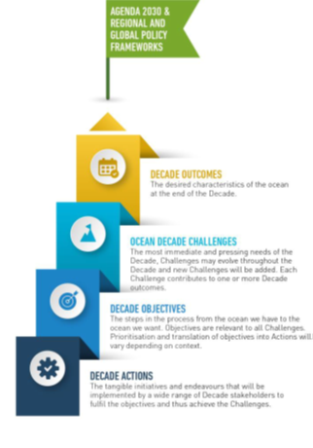
The Arctic region is closely interlinked with its marine environment, and currently is experiencing dramatic change. This change is impacting local communities and ecosystems but also has regional and global implications. It is therefore important to align efforts towards a coordinated regional Action Plan to harvest the maximum benefit from the momentum of the global process.
The content of the Action Plan should address three levels of activities, which are mutually interlinked and thus dependent on each other:
Knowledge generation driven by research and observations
Policy development implementing the new insights into societal action
Innovation providing society (industry, government, public) with the means and arenas to operate within agreed policies and targets

Purpose of the non-paper
This short non-paper (i.e. an unofficial paper to inform discussions) was prepared by the Arctic Ocean Task Force to support the seven working groups that will draft the input to the final plan. The development of the final Action Plan should be inspired by and recognize existing frameworks and activities. It should also strive to demonstrate the connection between drivers from industry, the general public, policymakers, Arctic residents and scientific stakeholders and the specific “Arctic challenges” and potential solutions (i.e. the proposed actions).
Working groups are therefore encouraged to use this non-paper as a starting point for developing discussions, including policies that might be more easily implemented or instituted if certain action(s) are performed.
Spatial scoping
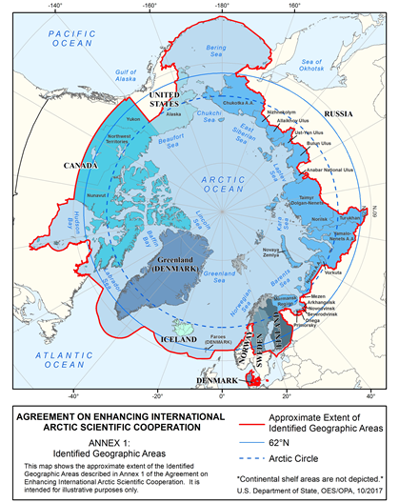
The Task Force suggests using the delineation of the Arctic marine area used in the “Agreement on enhancing International Arctic Scientific Cooperation” (map to the right) as a suitable spatial demarcation in relation to topics and policies to consider in the drafting of the action plan. This delineation is different from the International Maritime Organization’s (IMO) demarcation of “Arctic Waters”, which e.g. does not cover the areas around Iceland, as well as other definitions of the Arctic including thatused by the Arctic Monitoring and Assessment Program (AMAP).
It is also important to note that several nations outside the area are operators of regional or international observation, research and innovation programmes that are highly relevant to the Ocean Decade process.
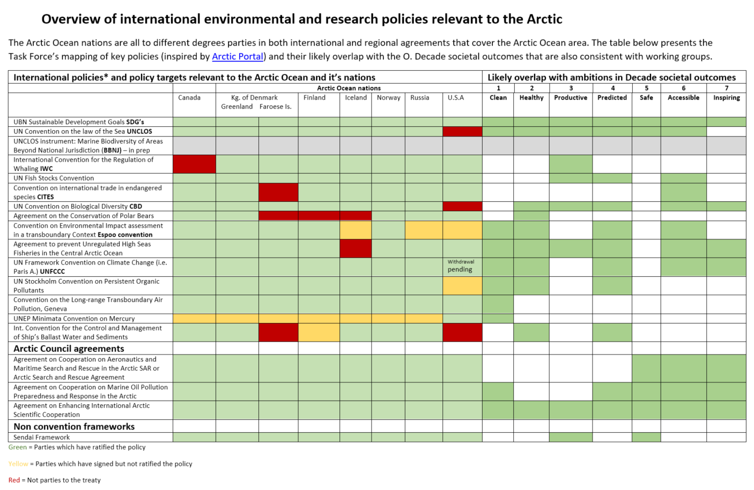
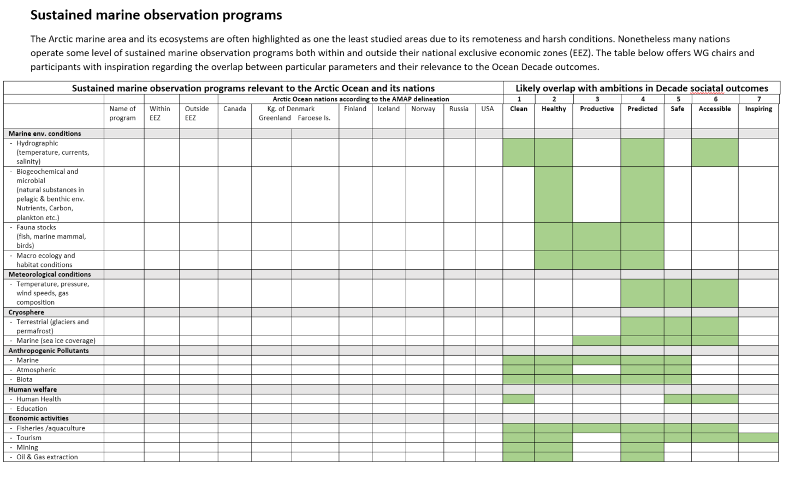
Funding of research, observation programmes and innovation
Most activities in the Arctic marine area, be they industrial, governmental, public or scientific, depend highly on an array of supporting services and enabling technologies. This includes the availability of chartered sailing routes, weather and ice forecasts, echo sounders, gps-transmitters and communications. Large-scale international investments for example in space-based satellite systems, are an excellent example of how coordinated international investments in innovation can support a large range of Arctic activities and further initiate local innovation and regional societal development.
This development would not have been possible without considerable long term financial investment such as undertaken for satellite based earth observation and communication programs. The challenge now is to identify and strengthen other existing innovative research and observation programs, including those that are earth-surface based. One consideration which actions should consider is therefore where likely funding could be obtained in the drafting of actions

C2: Guidance on the interpretation of the Ocean Decade societal outcomes – and the working groups

Working group 1: How to achieve - A clean ocean where sources of pollution are identified, reduced or removed

Chairs:
- Colin Moffat – Scottish Government (UK)
- Toril Inga Røe Utvik - Equinor (Norway)

Ocean Decade definition of the societal outcome:
Society generates a vast range of pollutants and contaminants including marine debris, plastic, nutrients, underwater noise, pharmaceutical pollutants and heavy metals. These pollutants and contaminants derive from a wide variety of land and sea-based sources, including point and non-point sources. The resulting pollution is unsustainable for the ocean and jeopardises ecosystems, human health, and livelihoods. It will be critical to generate interdisciplinary and co-produced knowledge on the causes and sources of pollution and its effects on ecosystems and human health. This knowledge will underpin solutions co-designed by multiple stakeholders to eliminate pollution at the source, mitigate harmful activities, remove pollutants from the ocean, and support the transition of society into a circular economy.
Examples of potential issues and actions to be discussed by working groups based on the Task Force’s interpretation of the outcome.
Challenge
Sustained international coordinated pollution source and distribution mapping
Characterising new threats to Arctic marine ecosystems and the risk to environment and humans of current and future arctic marine pollution
Ensuring the necessary local cooperation across the Arctic
Actions
Advance the categorisation of relevant pollutants in the Arctic
Increased international coordination of sustained mapping and reporting efforts
Regionally coordinated action plans to manage pollution sources
Active involvement of local communities

Working group 2: How to achieve - A healthy and resilient ocean where marine ecosystems are understood and managed
Chairs:
- Brendan Kelly - University of Alaska Fairbanks (USA)
- Katherine Richardson - University of Copenhagen (Denmark)

Ocean Decade definition of the societal outcome:
Degradation of marine ecosystems is accelerating due to unsustainable activities on land and in the ocean. To sustainably manage, protect or restore marine and coastal ecosystems, knowledge of these ecosystems, and their reactions to multiple stressors, needs to be enhanced. This is particularly true where multiple human stressors interact with climate change, including acidification and temperature increase. Such knowledge is critical to developing tools to implement management frameworks that build resilience and avoid ecological tipping points, and thus ensure ecosystem functioning and continued delivery of ecosystem services for the health and wellbeing of society and the planet as a whole.

Examples of potential issues and actions to be discussed by working groups based on the Task Force’s interpretation of the outcome.
Challenge
Understand the effects of multiple stressors on arctic marine ecosystems
Understand what solutions will be best to protect, monitor, manage and restore ecosystems and their biodiversity
Ensuring that progress also benefits local Arctic communities
Actions
Identification of the key stressors at key locations, their temporal variability and their source(s)
Study of the impacts on biodiversity and function, resulting from exposure to multiple stressors
Improved understanding of the impacts of multiple stressors on marine ecosystem services, in particular climate change
Development of marine spatial planning initiatives, marine protected areas and ecosystem-based management practices towards good Arctic ocean stewardship
Initiate internationally coordinated habitat restoration or protection initiatives.
Identification of the state, functioning and value of Arctic marine geosystems, including diversity and heritage in relation to designation of marine protected areas

Working group 3: How to achieve - A productive ocean supporting sustainable food supply and a sustainable ocean economy.
Chairs:
- Anne Christine Brusendorff - ICES (International)
- Henry Huntington – The Ocean Conservancy (USA)
Ocean Decade definition of the societal outcome:
The ocean will be a foundation for future global economic development and human wellbeing, including assuring food security and secure livelihoods for hundreds of millions of the world’s poorest people. Knowledge and tools to support the recovery of wild fish stocks, deploy sustainable fisheries practices, and support the sustainable expansion of aquaculture, while protecting essential biodiversity and ecosystems, will be essential. The ocean also provides critical goods and services to a wide range of established and emerging industries including extractive industries, energy, tourism, transport and pharmaceutical industries. Each of these sectors has specific needs in terms of increased knowledge, and support to innovation, technological development and decision support tools to minimise risk, avoid lasting harm, and optimise their contribution to the development of a sustainable ocean economy.
Examples of potential issues and actions to be discussed by working groups based on the Task Force’s interpretation of the outcome.
Challenge
Predicting the potential future opportunities for a sustainable blue Arctic economy
Ensuring that progress also benefits local Arctic communities
Ensure long-term food security in the Arctic
Developing a model for sustainable management of marine resources, which is supported by local stakeholders
Future needs for marine-geological resources that are essential for a sustainable economic development, e.g. quartz sand, critical minerals such as REE’s
Action
Assess current and future exploitation potential of wild fish/seafood stocks and aquaculture in the Arctic
Identify main challenges and solutions for increasing or managing different types of sustainable tourism, offshore renewable energy or extractive industries
Development of geodiversity variables and operational indicators to assess the pressure impact on Arctic marine geosystems and ecosystems, and to support sustainable planning and management of resources

Working group 4: How to achieve - A predicted ocean where society understands and can respond to changing ocean conditions
Chairs:
- Sandy Starkweather - NOAA (USA)
- Mark Payne – Technical University of Denmark (Denmark)
Ocean Decade definition of the societal outcome:
The vast volume of the ocean is neither adequately mapped or observed, nor is it fully understood. Exploration and understanding of the changing ocean including its physical, chemical and biological components and interactions with the atmosphere and cryosphere is essential, particularly under a changing climate. Such knowledge is required from the land-sea interface along the world’s coasts to the open ocean, and from the surface to the deep ocean seabed. It needs to include past, current and future ocean conditions. More relevant and integrated understanding and ultimately prediction of ocean ecosystems and their responses and interactions will underpin the implementation of ocean management that is dynamic and adaptive to a changing environment and changing uses of the ocean.
Examples of potential issues and actions to be discussed by working groups based on the Task Force’s interpretation of the outcome.
Challenge
The Arctic marine environment is inadequately mapped, observed, and poorly understood
Climate change impacts on established and emerging maritime industries
Enabling Arctic local communities to respond adequately to increasing levels of ecosystem change
Action
Establish commitment for and develop a coordinated sustained Arctic marine observation program encompassing biotic, abiotic, industrial and socio-economic parameters
Strengthen capacity for prediction of arctic marine ecosystems and their responses and interactions
Develop processes inclusive of Indigenous knowledge and highly local needs
Identifying the potential impacts of Arctic change on established and emerging maritime industries and how to address them, e.g. opening of new Arctic shipping routes

Working group 5: How to achieve - A safe ocean where life and livelihoods are protected from ocean-related hazards
Chairs:
- Matthew Owen – Geological Survey of Denmark and Greenland (Denmark)
- Lena Holm Saxtoft - SKULD (Denmark)
Ocean Decade definition of the societal outcome:
Both geophysical and human induced hazards create devastating, cascading and unsustainable impacts for coastal communities, ecosystems, and economies. The changing frequency and/or intensity of weather- and climate-related hazards is exacerbating these risks. Mechanisms and processes for assessing the risk, mitigating, forecasting and warning of these hazards and formulating adaptive responses are required to reduce short- and longer-term risks on land and at sea. Higher density ocean data and improved forecast systems—including those related to sea level, marine weather and climate are needed from near real time through decadal scales. When these enhancements are linked to education, outreach, and communication, they will empower policy and decision-making and mainstream individual and community resilience.
Examples of potential issues and actions to be discussed by working groups based on the Task Force’s interpretation of the outcome.
Challenge
To identify and quantify current and future threats to coastal Arctic communities, and develop mitigation and forecasting approaches
Ensuring safe shipping in increasingly ice free waters
Action
Establish the need for coordinated early warning systems for marine, incl. geo-hazards
Development of a coordinated Arctic Ocean Observation System, covering key societal, environmental and industrial priorities
Understanding present gaps and needs in shipping safety and SAR coverage

Working group 6: How to achieve - An accessible ocean with open and equitable access to data, information and technology and innovation.
Chairs:
- Nicole Biebow – Alfred Wegener Institute (Germany)
- Molly McCammon – Alaska Ocean Observing System (USA)

Ocean Decade definition of the societal outcome:
Inequalities in ocean science capacity and capabilities need to be eradicated through simultaneously improving access to data, knowledge, and technology, and by increasing skills and opportunities to engage in data collection, knowledge generation and technological development. Increased dissemination of relevant ocean knowledge to the scientific community, governments, business and industry, and the public through relevant and accessible products will improve management, innovation and decision-making contributing to societal goals of sustainable development.
Examples of potential issues and actions to be discussed by working groups based on the Task Force’s interpretation of the outcome.
Challenge
To optimise transnational sharing of data and infrastructure relevant for Arctic marine communities, research and development
Development of enabling technologies capable of being used consistently in Arctic environments
To ensure access to data, information and products across wide range of internet and bandwidth capacity
Action
Identification of key data, with high demand across sectors
Development of a system for a higher degree of open access to Arctic data and infrastructure and sharing of best practices
Partnerships on the development of key high demand technology needed in the Arctic for the Blue Economy
Development of a system capable of disseminating data products identified as key priorities in other working groups, including those of an integrated Arctic Observing System

Working group 7: How to achieve - An inspiring and engaging ocean where society understands and values the ocean in relation to human wellbeing and sustainable development.

Chairs:
- Raychelle Danielle – Pew trust (USA)
- Gunn-Britt Retter – Saami Council (Norway)

Ocean Decade definition of the societal outcome:
In order to incite behaviour change and ensure the effectiveness of solutions developed under the Decade there needs to be a step change in society’s relationship with the ocean. This can be achieved through ocean literacy approaches and other public awareness and education tools that will build a significantly broader understanding of the economic, social, and cultural values of the ocean and the plurality of roles that it plays to underpin health, wellbeing and sustainable development. This outcome will highlight the ocean as a place of wonder and inspiration, thus also influencing the next generation of scientists, policy makers, government officials, managers and innovators
Examples of potential issues and actions to be discussed by working groups based on the Task Force’s interpretation of the outcome.
Challenge
Recognition of the importance of the role of the marine ecosystems as basis for sustainable development in the Arctic
Ensuring increasing capacity building among Arctic people and stakeholders working in the Arctic Blue Economy
Action
Facilitate the integration and recognition of Indigenous knowledge across all themes of the Arctic Action plan
Efforts on Arctic capacity building (ocean education) and resource-sharing between countries and communities
Development of an Arctic regional cooperation on ocean literacy approaches, including of strategies for contributions to global ocean literacy initiatives that focus on the long range effects of Arctic change
Development of global outreach initiatives on improving understanding of the economic, social, and cultural values of the ocean and the roles that it plays to underpin health, wellbeing and sustainable development
Recognizing the importance of shared logistical platforms and building international collaboration to meet the challenges of working in the Arctic

C3: List of participants and institutions which have provided input to the process

To be written following the end of the consultation

Intergovernmental Oceanographic Commission (IOC) of United Nations Educational, Scientific, and Cultural Organization (UNESCO).
Tromsø workshop outcomes link
The Agreement on enhancing international Arctic scientific cooperation (2017). Available on: https://oaarchive.arctic-council.org/handle/11374/1916
See Annex A for a description of the Arctic Action Plan development process.
Agreement on Enhancing International Arctic Scientific Cooperation negotiated under the auspices of the Arctic Council and ratified by the eight Arctic states. https://oaarchive.arctic-council.org/handle/11374/1916
AMAP, ICES, PAME, PICES and CAFF
as suggested by IPBES
The newly established Arctic Science Funders Forum (ASFF) could be developed to play an important role in the coordination of arctic research.
For example working groups established under the Arctic Council.
For example scientists based initiatives such as Synoptic Arctic Survey (SAS) and Distributed Biological Observatory (DBO).
FAIR (findable, accessible, interoperable and reusable); CARE (Collective benefit, Authority to control, Responsibility and Ethics)
Integrated Ecosystem Assessment: Barents (ICES 2019), the Arctic Council’s approach to managing marine ecosystems (Logerwell and Skjoldal 2019), Indigenous/Federal collaborations in Canada to protect marine ecosystems (Government of Canada 2011), UNESCO’s identification of globally significant ecosystems in the Arctic Ocean (Speer et al. 2017),

